# AcqManager

# Menu Connection Guide (*Wireless and Wired Links*)

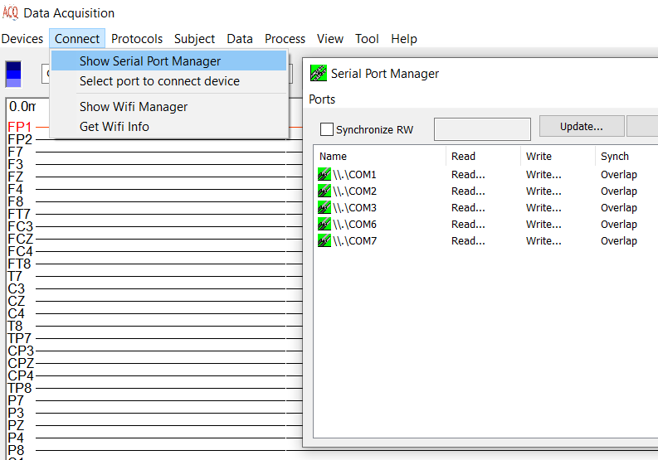

# DISCLAIMER

Software develops quickly to take the advantages of hardware and new algorithms. We have used reasonable effort to include accurate and up-to-date information in this manual; it does not, however, make any warranties, conditions or representations as to its accuracy or completeness. We assume no liability or responsibility for any errors or omissions in the content of this manual. Your use of this manual is at your own risk. Under no circumstances and under no legal theory shall the authors be liable for any indirect, direct, special, incidental, punitive, exemplary, aggravated or consequential damages arising from your use of this manual.

Features and specifications of this software program are subject to change without notice. This manual contains information and images about AcqManager, its user interface, GUI and its other signal processing algorithms, publications that are protected by copyright.

All rights reserved. This publication may be reproduced, stored in a retrieval system, or transmitted, in any form or by any means, electronic, mechanical, photocopying, recording, or otherwise, with prior permission by the authors.

*Sending Your Comments and Critiques:* We’d like to hear from you. Your comments and suggestions for improving this document are welcome and appreciated. Please e-mail your feedback to support@mecurer.com

Thank you.

Contents

AcqManager 1

Menu Connection Guide (*Wireless and/or Wires*) 1

DISCLAIMER 2

Contents 3

*Warnings and Cautions* 4

Preface 5

Using Menu Connect 6

Selecting Connection (Data Transfer/Communication) 6

Show Serial Port Manager (~256 COMs) 8

Select port to connect device 8

Show Wifi Manager 11

Get Wifi Info 12

Show Bluetooth Manager 12

Get Bluetooth Info 12

Show Sound Recorder 13

Show Video Recorder 13

Use FTDI USB COM 13

# *Warnings and Cautions*

This software supports data acquisition for magnetoencephalography (MEG), electroencephalography (EEG) and other bioelectromagnetic signals. Though MEG and EEG waveforms appear similar, they have different unit in amplitude. If the MEG and EEG data recorded simultaneously, their time unit or temporal resolution is typically the same.

Modern MEG/EEG systems typically have MEG/EEG sensor/electrode channels as well as other channels. For example, trigger channel, head-localization channels and additional ADC (analog-to-digital) channels. To avoid problems, please pay attention to the channel names and the amplitude value/unit. Their values may be of different orders of magnitude. Unexpected results may occur if their values are mixed in measurements.

When performing waveform analysis, regardless of whether MEG or EEG or both are displayed, ensure that the data are appropriately filtered with DC-offset/linear-trend removal. If the waveforms had very large amplitude (e.g. > 3 pt), it is recommended that you identify possible noise.

There are a set of source localization algorithms in the program. Each source localization algorithm has been designed and tested for specific reasons. To ensure the quality and visibility, all source localization algorithms will generate a volumetric source image, which can be considered as an image with millions of “dipoles” or multi-value-voxel, which is significantly different from the conventional magnetic source imaging (MSI) or equivalent current dipoles.

Head movement during MEG recordings may affect the accuracy of source imaging. If subjects move too much during MEG recordings, the MEG results are more than likely poor.

The accuracy of the structural images (MRI/CT) may also affect the MEG results if the conventional magnetic source imaging (MSI) is used. If MRI/CT is distorted, the combination of MEG/MRI/CT will be low-quality. In addition, multiple local sphere, head model or other structural constrained source localization my internally use the MRI/CT images. Any analysis based on those distorted images may yield unexpected or poor results.

The following warnings and cautions appear in this guide. Please ensure you are aware of all the operations and interpretations.

# Preface

The Main Frame is one of the core windows of AcqManager software. It is used as the primary tool to view MEG, EEG, MCG, ECG, triggers and other data, mark and classify the data, and identify results of interest for academic or clinical purposes. Importantly, the Main Frame provides graphic user interface (GUI) for access other function. In other words, it is also often used to launch other windows such as source localization.

This guide describes the operation of the AcqManager application for MEG/EEG/MCG/ECG. Though there are many functions related to MRI/CT, analyses of MRI/CT are not the focuses of this guide.

*Determining the Software Version*

In the Main Frame: select Help -> About.

The About Dialog will show the version of the software.

*Intended Audience*

This guide is intended for anyone needing to record and view (online) data with an appropriate hardware system. It assumes the technologist/operator is familiar with standard MEG/EEG/MCG/ECG procedures and with the Windows operating systems.

*Document Structure*

Documents are generally provided in both Microsoft Word® format and Adobe® Acrobat® PDF (Portable Document Format). All editions are distributed on Flash Driver, CD or websites with the related software, and include bookmarks and hyperlinks to assist navigating the document. Please feel free to send your critiques, corrections, suggestions and comments to support@mecurer.com.

*Conventions*

Numeric: Numeric values are generally presented in decimal but in special circumstances may also be expressed in hexadecimal or binary. Hexadecimal values are shown with a prefix of 0x, in the form 0x3D. Binary values are shown with a prefix of 0b, in the form 0b00111101. Otherwise, values are presumed decimal.

Units: Units of measure are given in metric. Where measure is provided in imperial units, they are typically shown in parenthesis after the metric units. Biomagnetic signal strength is given in Teslas (T), the SI unit of flux density (or field intensity) for magnetic fields, also known as the magnetic induction. Typical signal strengths in biomagnetic measurements are in the order of pT (picoteslas = 10-12) or fT (femtoteslas = 10-15). Electrical signal strength is given in volts (V). Bioelectrical activity is typically quite small, measured in microvolts (mV).

# Using Menu Connect

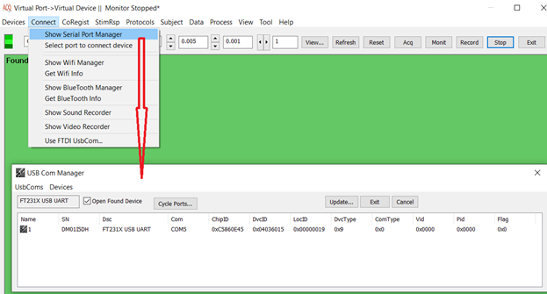

Figure 1. AcqManager Connect allows users to checking, managing all available serial ports.

This menu provides access to a set of devices that are supported by AcqManager. Acq Manager is optimized for USB virtual serial ports (COMs) because USB has become a standard “plug-and-play” port for modern computers.

# Selecting Connection (Data Transfer/Communication)

The software supports an increasing list of methods for data transferring or communication. The commonly used methods for MEG/EEG are serial ports (COM), blue tooth and Wifi (Wi-Fi).

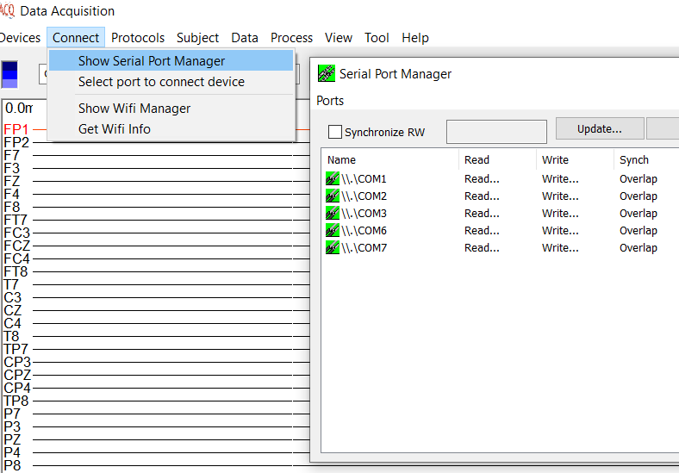Figure 1. AcqManager Connect allows users to checking, managing all available serial ports.

(1) Select Menu “Connect”-> Select Type of connections

For example: Serial Port Manager

(2) Setup a set of serial ports

A typical computer with Windows 7/8/10 can support up to 256 serial ports which are more than enough for recording biomagnetic and bioelectric signals.

# Show Serial Port Manager (~256 COMs)

AcqManager can a set of bioelectromagnetic systems. Biomagnetic (e.g. MEG) systems are typically more complicated than bioelectric (EEG) systems. Following systems are commonly used in research and clinical environments.

# Select port to connect device

AcqManager can a set of bioelectromagnetic systems. Biomagnetic (e.g. MEG) systems are typically more complicated than bioelectric (EEG) systems. Following systems are commonly used in research and clinical environments.

# Wireless connection

The main wireless connections are Bluetooth and Wi-Fi. Bluetooth and Wi-Fi (Wi-Fi is the brand name for products using IEEE 802.11 standards) have some similar applications: setting up networks, printing, or transferring files. Wi-Fi is intended as a replacement for high-speed cabling for general local area network access in work areas or home. This category of applications is sometimes called wireless local area networks (WLAN). Bluetooth was intended for portable equipment and its applications. The category of applications is outlined as the wireless personal area network (WPAN). Bluetooth is a replacement for cabling in various personally carried applications in any setting and also works for fixed location applications such as smart energy functionality in the home (thermostats, etc.).

Wi-Fi and Bluetooth are to some extent complementary in their applications and usage. Wi-Fi is usually access point-centered, with an asymmetrical client-server connection with all traffic routed through the access point, while Bluetooth is usually symmetrical, between two Bluetooth devices. Bluetooth serves well in simple applications where two devices need to connect with a minimal configuration like a button press, as in headsets and speakers.

Both WiFi and Bluetooth are wireless technologies that are widely used to send and receive data wirelessly using radio signals. WiFi is for high-speed Internet access that connects nearby devices with each other and share the Internet via hotspots, whereas Bluetooth is used for connecting devices in short range.

Following is the features of WiFi and Bluetooth and how they are different from each other.

## What is WiFi?

WiFi stands for Wireless Fidelity. It defines any network based on the 802.11 standards, allows computers and devices with the required wireless capacity to communicate via radio waves with other computers or devices. IEEE established the 802.11 network standards, which describe how two wireless devices interact over the air. WiFi is a small network where smartphones, computers or other networkable devices are connected to each other wirelessly within a small range and share Internet using hotspots. WiFi uses radio frequency waves for wireless high-speed Internet and network connections. The size of a WiFi antenna is very small and can be put on small routers. WiFi can be used to connect printers, computers, gaming consoles, mobile and so on. WiFi specifies how to physically create a wireless network using approaches similar to the Ethernet standard. WiFi is built into most of today's computers and mobile devices, such as smartphones and handheld game consoles.

The WiFi standard is widely used in hotspots, which allow mobile users to connect to the internet using their WiFi-enabled wireless computers and devices. WiFi is also used in many homes and small companies to connect computers and devices wirelessly.

## What is Bluetooth?

Bluetooth was created under the IEEE 802.15.1 standard, which is used for wireless communication via radio transmissions. Bluetooth was first introduced in 1994 as a wireless replacement for RS-232 connections.

* Bluetooth connects a wide range of devices and establishes personal networks in the unlicensed 2.4 GHz spectrum. The device class determines the operating range. Many digital gadgets, such as MP3 players, mobile and peripheral devices, and personal computers, use Bluetooth.
* Unlike previous wireless technologies, Bluetooth provides high-level services such as file pushing, voice transmission, and serial line emulation to its network and devices.
* A scattered ad-hoc topology is the name given to the Bluetooth topology. It defines a **Piconet**, a small cell that consists of a group of devices connected in an ad-hoc manner.
* Bluetooth ensures data security and privacy when in use. It employs a 128-bit random number, a device's 48-bit MAC address, and two keys: authentication (128 bits) and encryption (256 bits) (8 to 128 bits). Non-secure, service level and link-level are the three modes of operation.

## Advantages of Using Bluetooth

* **Wireless** − One of the advantages of Bluetooth is that it transmits data without the use of any cables. You may send and receive files without having to worry about wires with this method. Wireless Bluetooth technology is also used in a variety of different applications. Personal security systems, finding devices, and health monitoring are examples of such uses.
* **Availability** − Bluetooth is now a standard function on most gadgets, including smartphones and tablets.
* **Usability** − Because of its ease of use, Bluetooth can be used by even the most inexperienced user. The Bluetooth pairing process is pretty simple. There is no need to install any software or drivers.
* **Efficiency** − Bluetooth is energy efficient which results in minimal power consumption. This is usually due to the Bluetooth low-power signals.

## Disadvantages of Using Bluetooth

* **Speed** − Data transfer is relatively sluggish in all wireless methods. In the case of Bluetooth, this is especially true. The transmission rate of Bluetooth 3.0 and Bluetooth 4.0 is 25 Mbps in general.
* **Range** − A Bluetooth connection has a maximum range of 100 meters. Bluetooth has a limited range of communication (typically lower than a WiFi connection).
* **Safety and security** − Even though Bluetooth has several security features, its security level is significantly lower because it utilizes radio frequencies. Bluetooth allows hackers to obtain your personal information quickly.
* **Reliability** − Even though the majority of Bluetooth implementations follow the standard, there are still worries about Bluetooth compatibility. This is due to a variety of factors, including profiles, drivers, and versions.

## Comparison between WiFi and Bluetooth

The following table highlights the major differences between WiFi and Bluetooth.

| **Key** | **WiFi** | **Bluetooth** |
| --- | --- | --- |
| Definition | WiFi stands for Wireless Fidelity. Wi-Fi is a technology that enables devices to connect to the Internet wirelessly. | Bluetooth is a wireless technology that is used to connect devices in short range. |
| Component | WiFi requires wireless adaptor on all devices and Wireless Router for connectivity. | Bluetooth requires an Bluetooth adaptor on all devices for connectivity. |
| Power Consumption | WiFi consumes high power. | Bluetooth is easier to use and consumes less power than Wi-Fi because it only requires an adapter on each connecting device. |
| Security | WiFi is more secure than Bluetooth. | Bluetooth is less secure than other wireless technologies such as WiFi. |
| Number of Users | Wi-Fi allows more devices and users to communicate at the same time. | Bluetooth restricts the number of devices that can connect at any given moment. |
| Bandwidth | WiFi needs high bandwidth. | Bluetooth has a low bandwidth. |
| Coverage | WiFi coverage area is up to 32 meters. | Bluetooth coverage area is about 10 meters. |

WiFi establishes a wireless network that allows computers and devices with the required wireless capacity to communicate via radio waves. Bluetooth, on the other hand, is a wireless technology that is used to connect devices in short range.

# Show Wifi Manager

For wireless MEG and EEG, we may use WiFi and BlueTooth to connect devices with computer. WiFi Manager provides a GUI for users to easily configure and use WiFi or network connections for data acquisition for MEG/EEG/MCG/MMG and many other modalities.

Wi-Fi or WiFi is a family of wireless network protocols, based on the IEEE 802.11 family of standards, which are commonly used for local area networking of devices and Internet access, allowing nearby digital devices to exchange data by radio waves. These are the most widely used computer networks in the world, used globally in home and small office networks to link desktop and laptop computers, tablet computers, smartphones, smart TVs, printers, and smart speakers together and to a wireless router to connect them to the Internet, and in wireless access points in public places like coffee shops, hotels, libraries and airports to provide the public Internet access for mobile devices. Wi‑Fi is a trademark of the non-profit Wi-Fi Alliance, which restricts the use of the term Wi-Fi Certified to products that successfully complete interoperability certification testing As of 2017, the Wi-Fi Alliance consisted of more than 800 companies from around the world. As of 2019, over 3.05 billion Wi-Fi enabled devices are shipped globally each year. Wi-Fi uses multiple parts of the IEEE 802 protocol family and is designed to interwork seamlessly with its wired sibling, Ethernet. Compatible devices can network through wireless access points to each other as well as to wired devices and the Internet. The different versions of Wi-Fi are specified by various IEEE 802.11 protocol standards, with the different radio technologies determining radio bands, and the maximum ranges, and speeds that may be achieved. Wi-Fi most commonly uses the 2.4 gigahertz (120 mm) UHF and 5 gigahertz (60 mm) SHF radio bands; these bands are subdivided into multiple channels. Channels can be shared between networks but only one transmitter can locally transmit on a channel at any moment in time.

Wi-Fi's wavebands have relatively high absorption and work best for line-of-sight use. Many common obstructions such as walls, pillars, home appliances, etc. may greatly reduce range, but this also helps minimize interference between different networks in crowded environments. An access point (or hotspot) often has a range of about 20 metres (66 feet) indoors while some modern access points claim up to a 150-metre (490-foot) range outdoors. Hotspot coverage can be as small as a single room with walls that block radio waves, or as large as many square kilometres (miles) using many overlapping access points with roaming permitted between them. Over time the speed and spectral efficiency of Wi-Fi have increased. As of 2019, some versions of Wi-Fi, running on suitable hardware at close range, can achieve speeds of 9.6 Gbit/s (gigabit per second)

To be safe, WiFi used in AcqManager hardware is identical to home WiFi. The World Health Organization (WHO) says, "no health effects are expected from exposure to RF fields from base stations and wireless networks", but notes that they promote research into effects from other RF sources.(a category used when "a causal association is considered credible, but when chance, bias or confounding cannot be ruled out with reasonable confidence"),this classification was based on risks associated with wireless phone use rather than Wi-Fi networks. The United Kingdom's Health Protection Agency reported in 2007 that exposure to Wi-Fi for a year results in the "same amount of radiation from a 20-minute mobile phone call". A review of studies involving 725 people who claimed electromagnetic hypersensitivity, "...suggests that 'electromagnetic hypersensitivity' is unrelated to the presence of an EMF, although more research into this phenomenon is required.

# Get Wifi Info

The rapid development of network connection makes wireless connection complicated. The Get WiFi Info function is to provide a way for you to obtain the WiFI information around the devices.

# Show Bluetooth Manager

Bluetooth is used for MEG/EEG/MCG/EKG and other medical modalities for wireless connections. Bluetooth is a short-range wireless technology standard that is used for exchanging data between fixed and mobile devices over short distances using UHF radio waves in the ISM bands, from 2.402 GHz to 2.48 GHz, and building personal area networks (PANs). It is mainly used as an alternative to wire connections, to exchange files between nearby portable devices and connect cell phones and music players with wireless headphones. In the most widely used mode, transmission power is limited to 2.5 milliwatts, giving it a very short range of up to 10 metres (33 ft). Bluetooth is managed by the Bluetooth Special Interest Group (SIG), which has more than 35,000 member companies in the areas of telecommunication, computing, networking, and consumer electronics. The IEEE standardized Bluetooth as IEEE 802.15.1, but no longer maintains the standard. The Bluetooth SIG oversees development of the specification, manages the qualification program, and protects the trademarks.[4] A manufacturer must meet Bluetooth SIG standards to market it as a Bluetooth device.[5] A network of patents apply to the technology, which are licensed to individual qualifying devices. As of 2009, Bluetooth integrated circuit chips ship approximately 920 million units annually. By 2017, there were 3.6 billion Bluetooth devices being shipped annually and the shipments were expected to continue increasing at about 12% a year.

# Get Bluetooth Info

AcqManager enables you to easily find Bluetooth information around the devices.

# Show Sound Recorder

Professional version of AcqManager provides the capability to record both biomagnetic signals (e.g., MEG/EEG/MCG/EKG) as well as sound simultaneously.

# Show Video Recorder

Professional version of AcqManager provides the capability to record both biomagnetic signals (e.g., MEG/EEG/MCG/EKG) as well as video simultaneously.

# Use FTDI USB COM

Serial ports are supported by operating system naturally. However, there is optimized chip for USB based COM. Although the functions are very similar or even identical, AcqManager enables users to select which type of COM will be used in data acquisition.

**Index**

E

Electroencephalography (EEG), **5**

F

femtoteslas, 6

M

Magnetic source imaging (MSI), 5

Magnetoencephalography (MEG), 5

Main Frame, 6

P

picoteslas, 6

T

Teslas (T),, 6